**IE3092**

**Information Security Project**

**CTF**

Progress Report

**Student Details**

|  |  |
| --- | --- |
| Student Number | Student Name |
| IT18032666 | Wishvajith B. L. D. V |
| IT18021912 | Ramanayaka A. M |

Links –

Video : <https://youtu.be/-rLlPdKh-ws>

GitHub : [github.com/VimukthiW/CryXSS-CTF](https://github.com/VimukthiW/CryXSS-CTF)

# **Summary**

Date Started –

Target Date –

Overall Progress – 40%

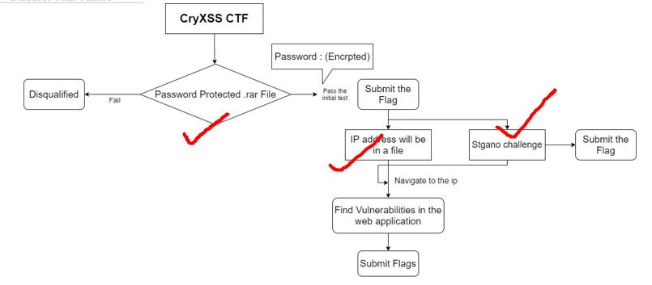

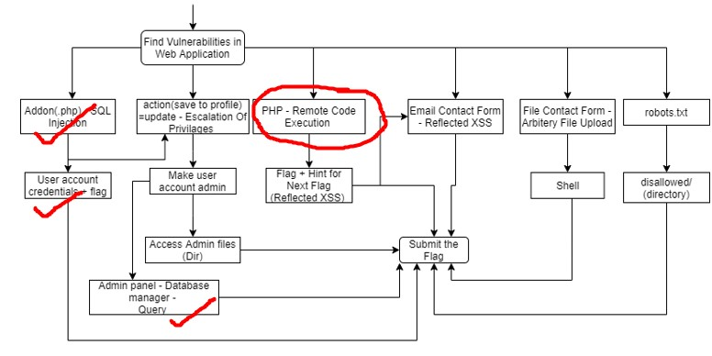

✔ - Implemented

○ – Discontinued

# **Web Application Progress**

**Implemented**

* Shop page – 80 %

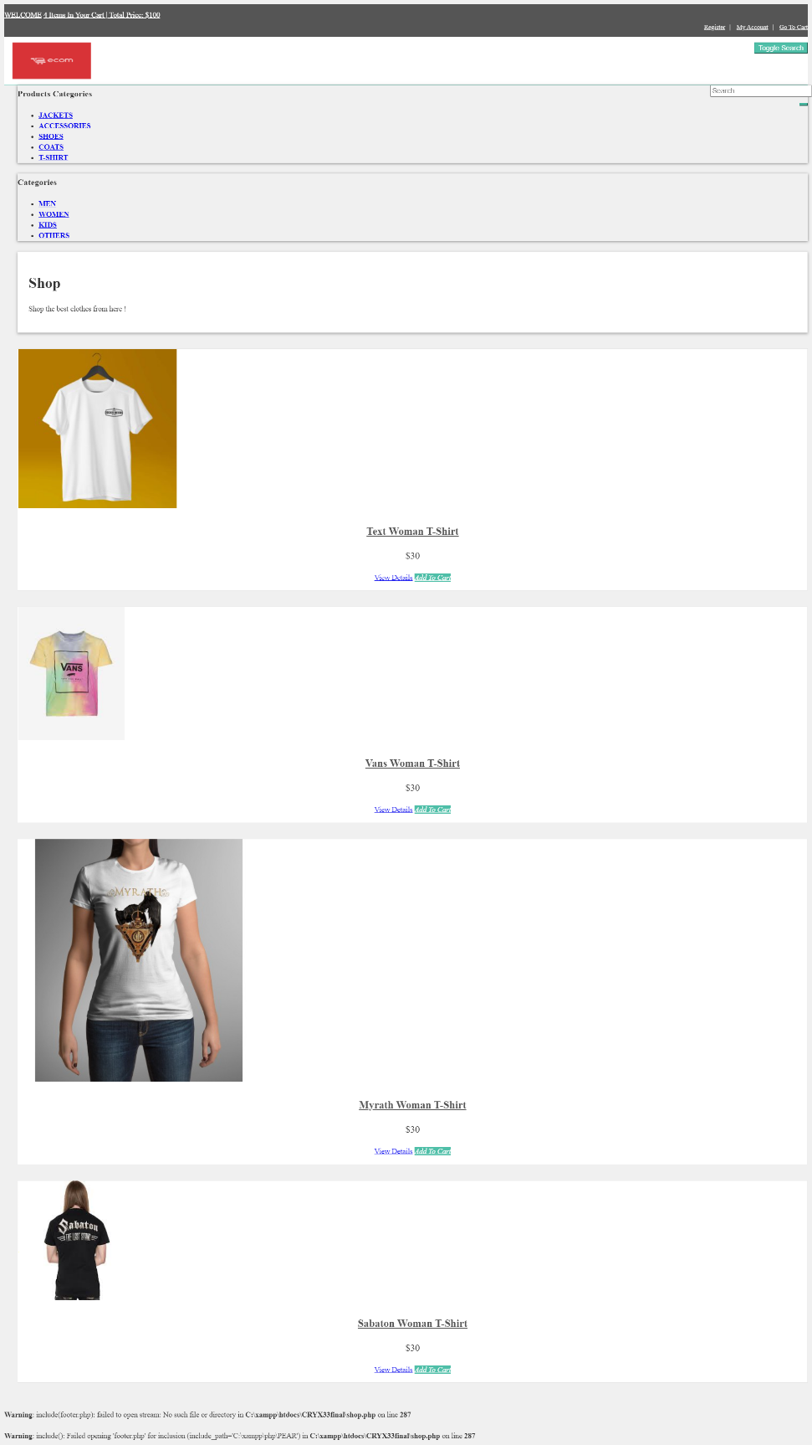

* Registration page – 100%

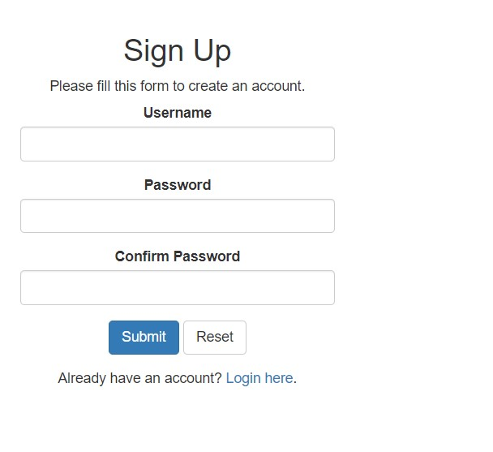

1. User’s password will be stored in a database with a salt value to generate randomness.

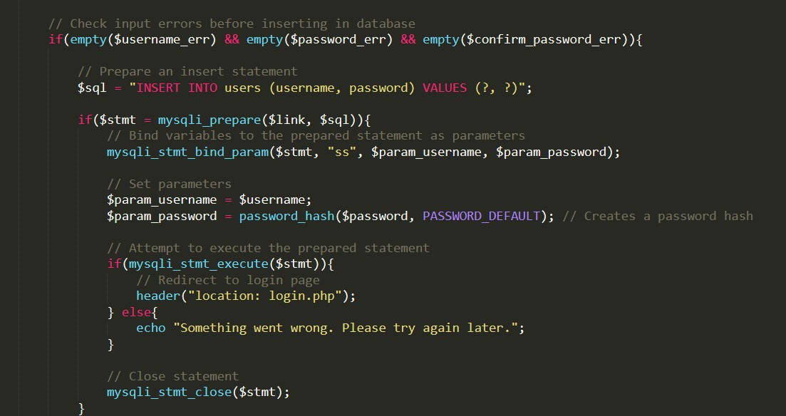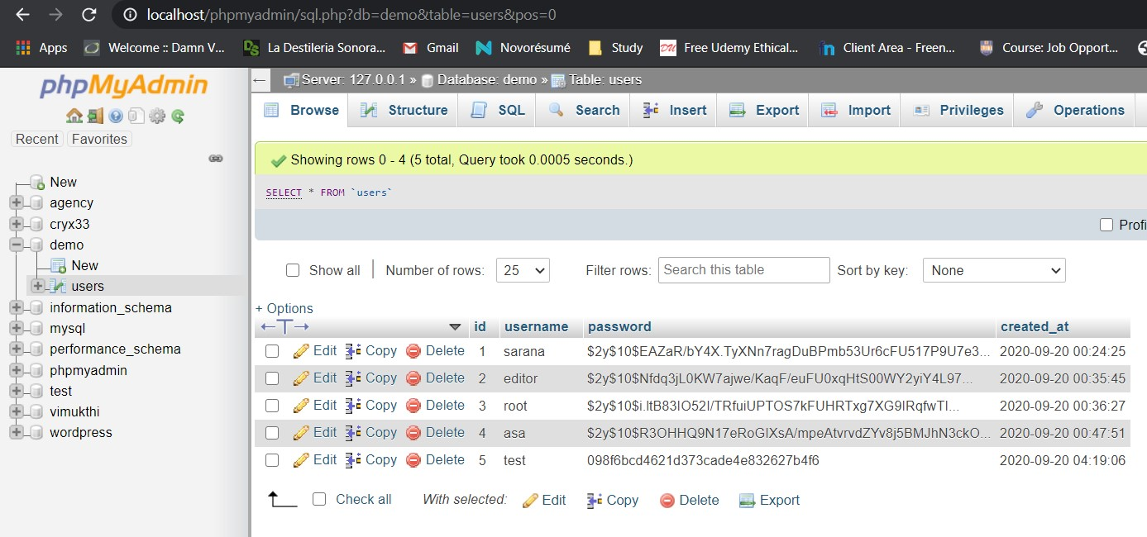

* Index page -100%



* Levels pages – 90%
* Login page – 100%

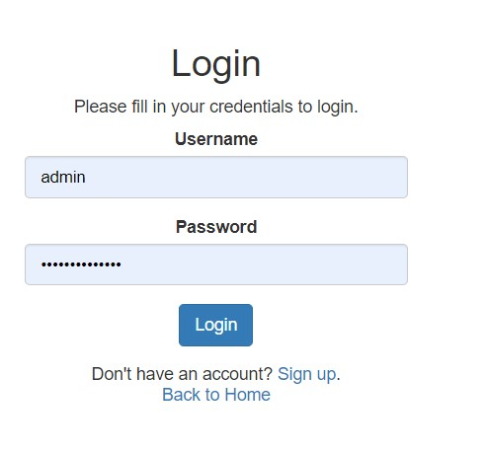

Validation

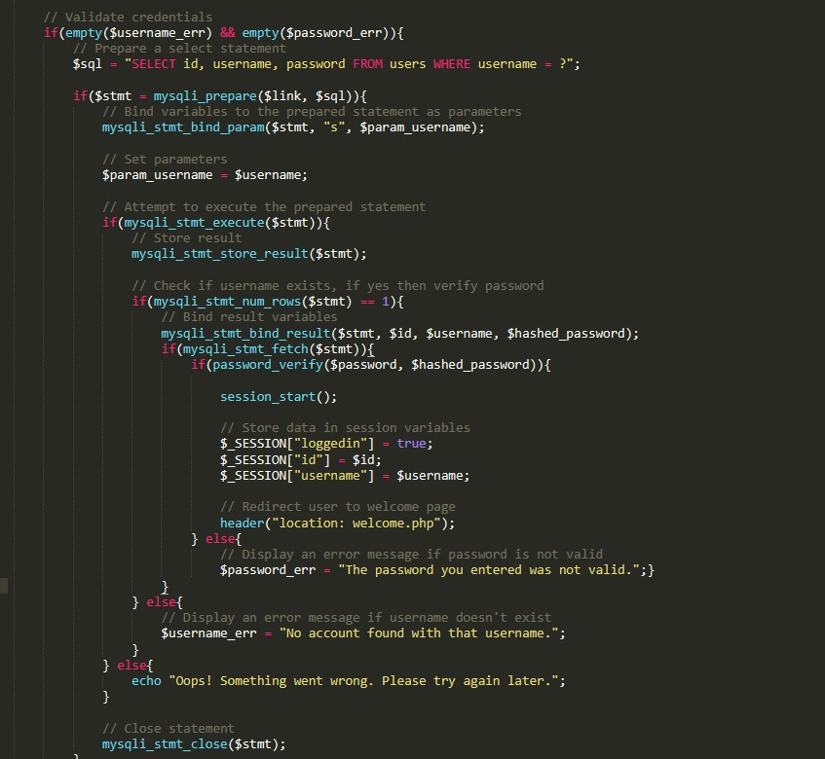

* Logout page – 100%
* Account page & password reset - 90%

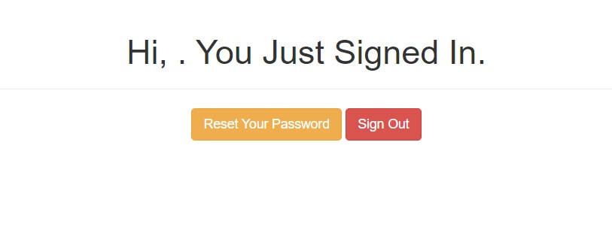

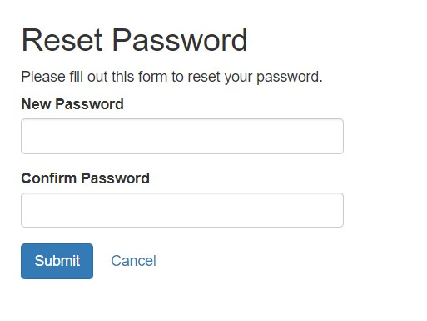

* Database for the user details

**To be implemented**

* Scoreboard
* Account management options – account page

Used – php for pages, SQL Database for User Detail handling

# **Architecture Progress**

## Level 01 – Preliminary Challenges

Progress – 90%

### Flag 01 – Crypto Challenge

|  |  |  |  |
| --- | --- | --- | --- |
| **Task** | **Implemented (Progress %)** | **To be Implemented** | **Notes** |
| 1. Encrypt the files with the flag id as the password | Implemented, 100% |  |  |
| 1. Create a read-me file including instructions and hints | Implemented, 100% |  |  |
| 1. Level 01 flag submission page | Implemented, 90% |  | Implemented post validation of the flag has to be corrected |
| 1. Display a hint for level 2 |  | TBI |  |

### Flag 02 – Stegano Challenge

|  |  |  |  |
| --- | --- | --- | --- |
| **Task** | **Implemented (Progress %)** | **To be Implemented** | **Notes** |
| 1. Embed the flag to an store item image | Implemented, 100% |  |  |
| 1. Level 02 flag submission page | Implemented, 90% |  | Implemented post validation of the flag has to be corrected |

## Level 02 – Web Application Challenges

Progress – 30%

### Flag 03 – SQL Injection Challenge

|  |  |  |  |
| --- | --- | --- | --- |
| **Task** | **Implemented (Progress %)** | **To be Implemented** | **Notes** |
| 1. Create a vulnerable login page | Implemented, 90% |  |  |
| 1. Level 03 flag submission page | Implemented, 90% |  | Implemented post validation of the flag has to be corrected |